

*shell programming lab*

aSsignment -16

**SUBMITTED BY: SUBMITTED TO:**

**AYUSH KUMAR JHA Dr. Dhiviya Rose**

**SAP ID - 500086400**

**Enrollment no - R200220083**

**B.C.A -I.O.T.**

## **Assignment Content**

Top of Form

EXPERIMENT – 13 in Manual

TITLE: Shell Scripts with data and time

Activities:

1. Write a shell script that determines the period for which a specified user is working on the system.

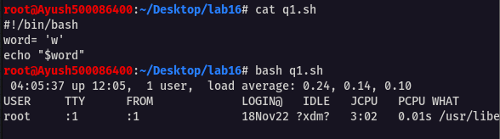

1. Write a shell script that accepts two integers as its arguments and computers the value of first number raised to the power of the second number.

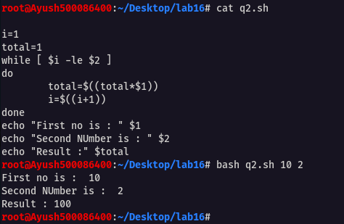

1. Write shell script that takes a login name as command – line argument and reports when that person logs in.

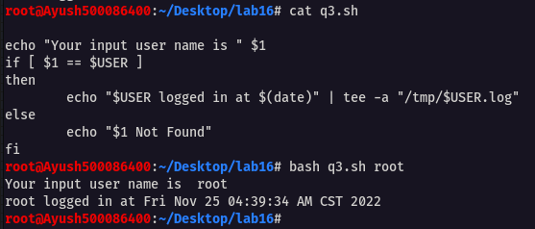

1. Write a awk script to find the number of characters, words and lines in a file? 16 linked list respectively.

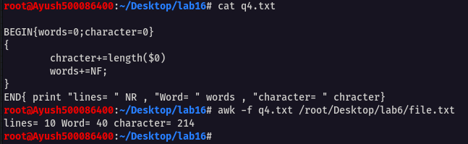

1. Ask user to enter his complete name (First Name, Middle Name, and Surname). Then, create a string variable that stores user’s complete name as a single string. Using this newly created string variable, print a message, ”Welcome to this class of Linux and Shell Programming, Mr. user-name.”

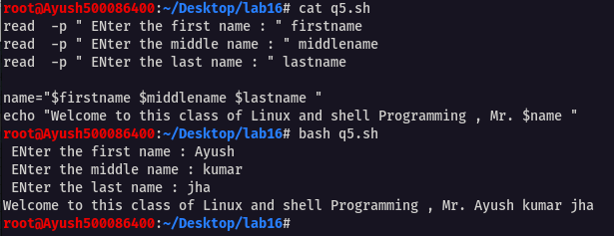

Bottom of Form